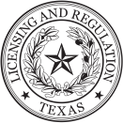
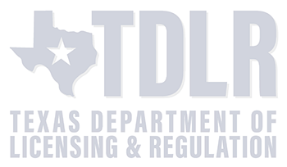



This certifies that the student named herein has successfully completed a six (6) hour driving safety course that
i
s approved and regulated by the Texas Department of Licensing and Regulation.

UNIFORM CERTIFICATE OF COMPLETION

This certifies that the student named herein has successfully completed a six (6) hour driving safety course that
is approved and regu
lated by the Texas Department of Licensing and Regulation.

UNIFORM CERTIFICATE OF COMPLETION

Under penalty of perjury, I certify that I have received six (6) hours of instruction.
Student’s Signature

WARNING
Altering, tampering, forgery
:
or misuse of the certificate may result in criminal fines up to $10,000 and/or up to 5 years imprisonment under
the Texas Penal Code and Texas Education Code.

Student Name:

Student DOB:

Student DL No:

Issue Date:

Provider:

Reason:

Completion Date:

If you have reason to believe this certi
ficate is not valid or the driving safety course taken did not meet the requirements in Texas
Administrative Code Chapter 84 or Texas Education Code Chapter 1001, please file a complaint with
TDLR

at

www.t
dlr.texas.gov/complaints

or
mail to
920
Colorado St, Austin, TX
78701.

STATE OF TEXAS DRIVING SAFETY COURSE

CERTIFICATE#

This certificate’s
validity can be verified within 5 days

of the issuance date
at
www.tdlr.texas.gov/DESSearch

Student Name and Mailing Address:

Court Information:

Under penalty of perjury, I certify that I have received six (6) hours of instruction.
Student’s Signature

Student Name:

S
tudent DOB:

Student DL No:

Issue Date:

Provider:

Completion Date:

CERTIFICATE#

This certificate’s
validity can be ver
ified within 5 days

of the issuance date at
www.tdlr.texas.gov/DESSearch

Student Name and Mailing Address:

If you have reason to believe this certificate is not valid or the driving safety course taken did not meet the requirements
in Texas
Administrative Code Chapter 84 or Texas Education Code Chapter 1001, please file a complaint with
TDLR

at

www.tdlr.texas.gov/complaints

or
mail to
78701.
920
Colorado St, Austin, TX

WARNING
:
Altering, tampering, forgery or misuse of the certificate may result in criminal fines up to $10,000 and/or up to 5 years
imprisonment under
the Texas Penal Code and Texas Education Code.

Reason:

STATE OF TEXAS DRIVING SAFETY COUR
SE

Fairview Municipal Ct.
Umayyah Mehmood
Coleto Creek Trl
1405
Prosper, TX 75078
CP007-20219924
Umayyah Mehmood
42115696
3/12/2002
CP007-DummiesTrafficSchool
11/07/2025
11/07/2025
Driving Infraction
Umayyah Mehmood
1405
Coleto Creek Trl
Prosper, TX 75078
CP007-20219924
Umayyah Mehmood
42115696
3/12/2002
CP007-DummiesTrafficSchool
11/07/2025
11/07/2025
Driving Infraction

